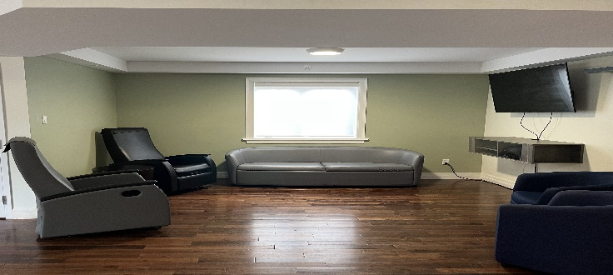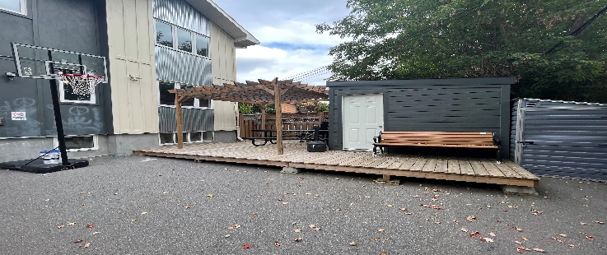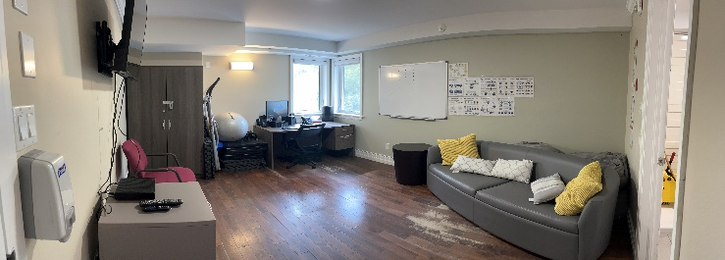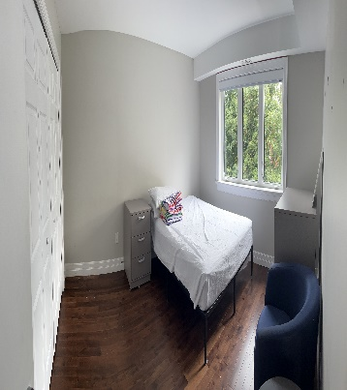

For more information please contact:

**Brandon Pasion, Residential Coordinator**

Phone: 613-690-5629

e-mail: [bpasion@jhsottawa.ca](mailto:bpasion@jhsottawa.ca)

**Alison Newson, Director of Child & Youth Services / Employment & Training**

Phone: 613-852-7048

e-mail: [anewson@jhsottawa.ca](mailto:anewson@jhsottawa.ca)

Residence Contact Info:

613-421-7770

Red Maple Supportive Residence

–

Justice Transition Home Project.

<https://johnhoward.on.ca/ottawa/>

redmapleresidence@jhsottawa.ca



Eligibility & Referral Criteria

Eligibility for access to the RMSR-JTH is determined using specific criteria, and **all** the requirements below must be met. The candidate must:

* Be confirmed eligible by Developmental Services Ontario (**DSO**) for MCCSS funded adult developmental services and supports.
* Have given consent to participate in the application and referral process.
* Be transitioning from or within the justice system.
* Be identified by justice officials as being at a high risk of committing an offence against persons, property or administration of justice.
* Have a suspected or diagnosed mental health issue and may also have corollary substance use issues.
* Be identified by a health or social services provider who is familiar with the individual (e.g., physician, registered nurse, mobile crisis worker, etc.) as posing a significant risk to the community or themselves.
* Have exhausted all potential available housing options, i.e., the DSO office has identified that the individual cannot be matched to any new or existing DS residential support options potentially available.

Services Provided

* 24/7 supervised accommodations
* Case management & Person-Centered Planning
* Individualized 1:1 supports and coaching for ADL/IADLs,
* Life skills & vocational skills programming & workshops
* On site nursing support
* Access to psychiatric and psychological services
* Behavioural Supports, including ABA and development of PBSPs
* Trauma responsive and DBT informed rehabilitative, psycho-social, and skills based programs to address identified risk factors and develop pro-social skills for increased independence.

Partnerships

RMSR has key partnerships with the **Royal Ottawa’ FACTT-DD program, Valor & Solutions - Community Networks of Specialized Care** (CNSC), and **Recovery Care Ottawa,** to provide individuals access to specialized clinical services/treatment, substance use treatment, addictions services and behavioural supports.

RMSR also works collaboratively with **Ottawa Police Services** with **Ottawa Probation & Parole** to support high risk individuals.

**Program Description**

The **Red Maple Supportive Residence (RMSR)** is a specialized transitional housing program, known as the *Justice Transition Home* (JTH), that supports individuals with developmental disabilities and complex needs (including dual diagnosis, concurrent disorders, and behavioural challenges) who are transitioning from provincial institutions and correctional facilities back into the community. The JTH bridges a gap in service by providing immediate housing, support and service to eligible individuals being released from correctional facilities without any other accommodation options and in need of intensive supports.

RMSR is intended to be a stepping-stone on the path towards recovery and working towards living with greater independence and self-determination in the community **It is interim, not permanent housing.**

The program provides temporary accommodations with intensive 24/7 supports, supervision and specialized clinical services. It aims to break the cycles of re-occurring high-risk, problematic and offending behaviours and reincarceration among the target client population by providing targeted interventions/programs, supports with ADL/IADLs, skill development and linkage with community supports and services.

The residence is comprised of both congregate living (bedrooms w/ shared common space) and self-contained one-bedroom apartments.

Centre of Research, Policy & Program Development