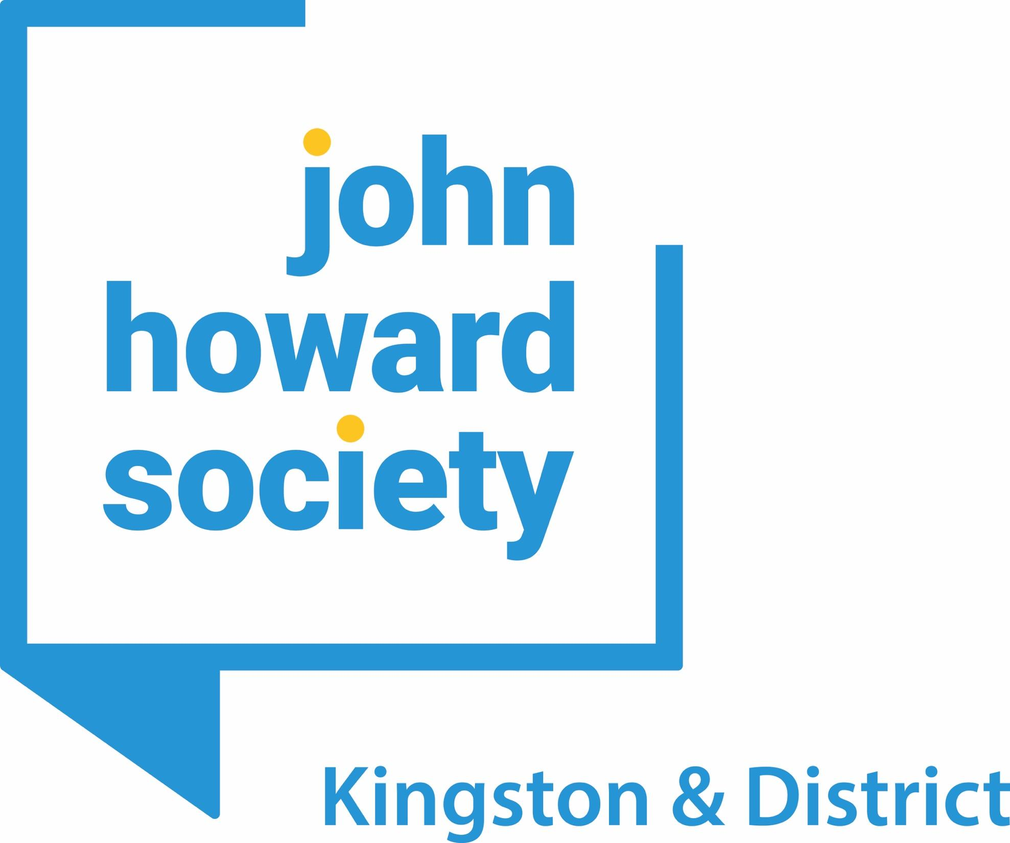

John Howard Society of Kingston and District

Strategic Plan 2021-2023

OUR 3-YEAR VISION

- Deliver Responsive, Inclusive and Impactful Programs and Services

John Howard of Society of Kingston & District will continue to deliver responsive and inclusive high-impact services to community members most in need, including those individuals who are currently incarcerated.

Given the complexity of the pandemic and its impact on the community, we will sustain our current services while strategically expanding key programs where the need is greatest.

The organization will deepen its investment in improving diversity and increasing equity in order to remove barriers experienced by community members, clients and staff. This will result in a culture of greater inclusion and representation that leverages our social capital in meaningful and just ways.

All of our services and programming will be informed by a diversity, inclusion and equity lens to dismantle racism and mitigate overrepresentation of Indigenous, Black and other racialized and marginalized communities in the justice system. The core values of this work will be amplifying the voices of those with living experience.

We will additionally be responsive to the needs of people experiencing addictions and mental health by providing advocacy and referrals through strong partnerships and alliances with community partners.

Meeting the Labour Market and Employment and Education Trends

Over the coming three years, we will meet employers’ needs while addressing our service users’ employment and education goals. This involves adapting our employment services to effectively and efficiently meet the Employment Ontario Transformation while increasing employability and economic resilience.

We will engage employers and service users in ways that respond to the new realities of the job market in a post pandemic context, with a special focus on youth, mental health, skilled workers and trades.

John Howard Society of Kingston & District will additionally continue to adapt our employment services for greater access through online and virtual platforms. We will invest in transforming our physical facility and location to best meet the community’s needs. This also includes actively increasing the visibility and image of ReStart by leveraging our organizational reputation for excellence in service.

Increasing Response to Housing and Homelessness

In the coming three years, we will explore strategies to increase the number of beds available to individuals leaving institutions. This will enhance our residential services and result in a greater offering of programming for our service users.

We will additionally explore the feasibility of increasing our housing capacity and community-based responses to the housing crisis in Kingston & District in partnership with others.

Expanding Services in District Locations

We will evolve district services, with a focus in Leeds and Grenville, as it relates to homelessness and housing and adult justice services. This will be accomplished through strategic partnerships and alliances.

Enhancing Institutional and Justice Services

We will continue to support those individuals who are incarcerated by evolving our programs and supports to respond to increasingly complex needs experienced as a result of the pandemic.

We will increase virtual supports provided to individuals in institutions due to restricted access due to COVID.

We will continue to adapt to changing court proceedings to ensure equitable access to the justice system. We will actively support clients through the court process to reduce barriers and increase equitable outcomes.

- Invest in Community Safety and Wellbeing

The organization will continue to collaborate with community partners and service providers to build a diverse and responsive network of referrals for our service users. Where there are service gaps, we will advocate and mobilize strategies with others to create solutions that address client needs.

Through our participation on broader community committees dedicated to developing integrated community responses, we will promote evidence-informed interventions to create impactful solutions.

As a local member of the John Howard Society of Ontario network, we commit to supporting systemic transformation as it relates to justice issues. We will leverage the province’s evidence-based research and policy reform work to inform and educate influencers and stakeholders in Kingston and District to collaborate to empower service users.

We will also continue to work with John Howard Society of Ontario by sharing our local expertise and experience to inform broader provincial solutions, responses, research and legislation.

We will connect with local leaders to promote community safety and to amplify our clients’ stories and experiences with justice access issues, with a focus on those who are overrepresented in the justice system. This includes promoting and educating the community about best practices and interventions as well as our organizational impact, outcomes, and results.

We will also collaborate closely with employers and economic development planning tables to promote a better understanding of the value and impact that our clients bring to the labour market.

As a result of this work, we will be increasingly seen as a go-to leader for effective community-based solutions.

- Foster Organizational Excellence and Resiliency

In the coming three years, John Howard Society of Kingston & District will continue to invest in a culture of excellence and inclusion among staff, volunteers and the Board. We will support our people through professional development, leadership development, performance management, team building, succession planning, and the enhancement of effective human resource systems.

Additionally, we will embed a diversity, inclusion and equity framework in all that we do.

We will integrate workplace flexibility to support a changing work environment. This includes optimizing our physical facility to provide confidential, safe, and accessible services. We will undertake a facility assessment to determine how best to utilize our program and office space for current and future needs.

In the next three years, we will continue to invest in organizational resiliency, knowing that sustainability depends on having strong administrative systems and leadership capacity. We will maintain and build our administrative capacity to meet the constantly changing demands on our organization. We will incorporate technological solutions to best meet our client’s needs and to support staff achievement.

Additionally, we will strengthen our use of evidence-based practices and outcome analysis to meet current and emerging community needs. We will also manage and allocate resources strategically.

OUR STRATEGIC PRIORITIES

- Deliver responsive, inclusive and impactful programs and services
- Invest in community safety and wellbeing
- Foster organizational excellence and resiliency

OUR STRATEGIC PRIORITIES & STRATEGIES

- Deliver responsive, inclusive and impactful programs and services

- Adapt services, enhance program evaluation and integrate technology to respond to evolving community needs
- Meet the changing and evolving labour market while meeting community members’ education and employment goals
- Explore the feasibility of increasing housing capacity and community-based responses to the housing crisis in Kingston & District

- Invest in community safety and wellbeing

- Evolve strategic partnerships to build an integrated service network that meets our service users’ diverse needs
- Expand services and programs in Leeds and Grenville
- Inform and influence local responses, solutions, and practices based on best practice and research

- Foster organizational excellence and resiliency

- Strengthen our organizational culture and capacity to foster resiliency, inclusion and impact
- Optimize our current physical facilities, programs and office space to best meet client, staff, and organizational needs
- Continue to build organizational sustainability by investing in administrative processes, integrating technological innovations, and strategic development

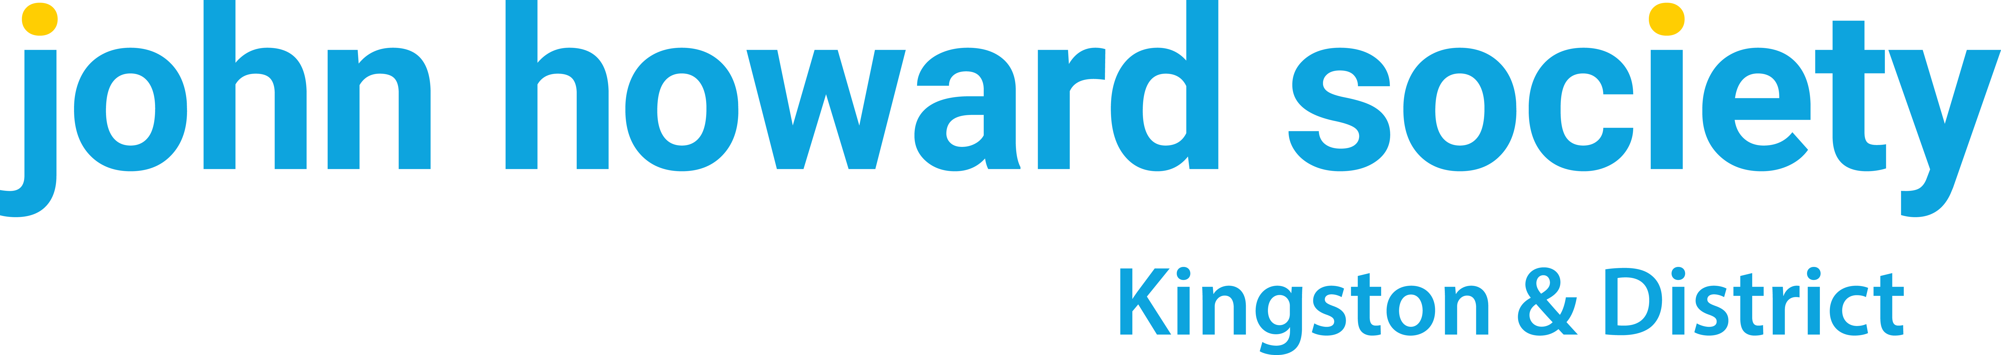
Strategic Plan 2021-2023

Mission:

Effective, Just, and Humane Responses to Crime, and its Causes

Vision:
To be a proactive leader promoting safer and more resilient communities through innovative and inclusive services.

Overarching Outcomes:
John Howard Society of Kingston & District (JHSK&D) is committed to delivering responsive, inclusive and high-quality services for community members experiencing personal and systemic barriers. In order to remove those barriers, in the coming three years, we will strengthen our commitment to diversity, equity and inclusion to create equitable access to services. We will continue to invest in community safety and well being through the promotion of best practices and evidence-based solutions. We will also build a strong resilient organization that adapts to evolving community needs and provides excellence in service.

PRIORITY ONE: DELIVER RESPONSIVE, INCLUSIVE AND IMPACTFUL PROGRAMS AND SERVICES
Strategies
- Adapt services, enhance program evaluation and integrate technology to respond to evolving community needs | - Meet the changing and evolving labour market while meeting community members’ education and employment goals | - Explore the feasibility of increasing housing capacity and community-based responses to the housing crisis in Kingston & District
Key Goals
- To embed a diversity, inclusion and equity framework into all programs and services.  - To position ReStart as the leading employment agency in Kingston within the provincial government’s EO Transformation.  - To evolve current institutional support to address institutional access issues during the pandemic and its future impacts.  - To continue to be responsive to increasingly virtual nature of court services.  - To utilize trends and program data and outcomes to better inform service delivery.  - To continue to embed technological innovation into service delivery to promote equitable access to services. | - To assess labour market needs and adapt employment programming to support the economic recovery needed to address the after affects of the COVID-19 pandemic.  - To focus specifically on the training and employment needs of youth, those with mental health issues, precariously employed workers, and people in the trades. | - To implement the best strategy to increase the capacity of residential services.  - To utilize emerging trends based on our new housing services in Leeds and Grenville to increase capacity and support for people experiencing a lack of housing and homelessness.  - To participate in local systems to advocate and promote housing resources and community-based supports for people with justice involvement in Kingston & District.

PRIORITY ONE: DELIVER RESPONSIVE, INCLUSIVE AND IMPACTFUL PROGRAMS AND SERVICES
Strategies
- Adapt services, enhance program evaluation and integrate technology to respond to evolving community needs | - Meet the changing and evolving labour market while meeting community members’ education and employment goals | - Explore the feasibility of increasing housing capacity in Kingston & District
3-Year Outcomes
- JHS K&D has a staff-led diversity, inclusion and equity framework that promotes in creased access to services across the organization.  - ReStart is positioned to secure continued funding for employment services.  - Institutional services has adapted In-reach Services to meet current needs within the prisons.  - Service delivery continues to be responsive and informed by community trends and program data and outcomes.  - The organization is maintaining and increasing virtual presence and access for all service users by integrating technological innovation. | - ReStart has leveraged its employment programs to address the economic impacts of COVID in the community to create best outcomes for employers and job seekers.  - ReStart continues to respond to and focus on those who are disproportionately impacted by systemic and personal barriers to employment and education. | - JHS K&D has increased the capacity of its residential services.  - The organization has increased its capacity to support people experiencing a lack of housing and homelessness.

PRIORITY TWO: INVEST IN COMMUNITY SAFETY AND WELLBEING
Strategies
- Evolve strategic partnerships to build an integrated service network that meets our service users’ diverse needs | - Expand services and programs in Leeds and Grenville | - Inform and influence local responses, solutions, and practices based on best practice and research
Goals
- To work with other service partners to build a more integrated and collaborative approach to meeting clients’ diverse needs by promoting in-person, virtual and warm referrals.  - To identify gaps in service and increase internal capacity while promoting best practice responses among other community partners.  - To work closely with employers and economic development tables to strengthen the impact of employment services. | - To integrate Connect Youth’s homelessness and housing services In Leeds and Grenville within the organization’s district services. | - To promote evidence-based research and policy reform within Kingston and District and to work with local leaders to promote positive change.  - To work closely with the John Howard Society of Ontario network to better inform and promote systemic change and broader solutions, responses, research and legislation.  - To amplify the stories of experiences of our clients with justice access issues while promote strategies that improve community safety.

PRIORITY TWO: INVEST IN COMMUNITY SAFETY AND WELLBEING
Strategies
- Evolve strategic partnerships to build an integrated service network that meets our service users’ diverse needs | - Expand services and programs in Leeds and Grenville | - Inform and influence local responses, solutions, and practices based on best practice and research
3-Year Outcomes
- JHS K&D has facilitated a rich network of responsive, collaborative and supportive partners who meet our clients where they are at and offer inclusive services.  - The organization has identified common and pressing service gaps and is exploring and accessing potential funding sources to develop services in-house.  - JHH K& D continues to integrate best practices into frontline service delivery models while promoting our unique approach amongst community service providers.  - Employment services are relevant and meeting the needs of clients, employers, and the broader economic trends of the Kingston community. | - JHS K&D offers a robust housing and homelessness program in the Leeds and Grenville community. | - The organization is recognized for its expertise and knowledge and is contributing to local solutions and advocacy for our client population.  - Our organization leverages the John Howard Society of Ontario research and policy to inform local practice.  - The stories and experiences of our clients are promoted and shape systems change work and community safety responses.

PRIORITY THREE: FOSTER ORGANIZATIONAL EXCELLENCE AND RESILIENCY
Strategies
- Strengthen our organizational culture and capacity to foster resiliency, inclusion and impact | - Optimize our current physical facilities, programs and office space to best meet client, staff, and organizational needs | - Continue to build organizational sustainability by investing in administrative processes, integrating technological innovations, and strategic development
Goals
- To embed a diversity, inclusion and equity framework into governance and all operations.  - To support our staff teams and unique organizational culture through professional development, leadership development, performance management, team building, succession planning and effective human resource systems. | - To support a changing work environment by optimizing physical facility through utilizing technology and flexible work arrangements.  - To explore strategies to explore expansion of physical space for increased service capacity. | - To sustain and expand organizational and administrative capacity to support service outcomes.  - To integrate technology to strengthen organizational efficiency and effectiveness while maintaining quality client service.  - To secure new and emerging funding to strategically develop programs that address identified service gaps.
3-Year Outcomes
- The organization is integrating an ARAO framework into its programming, operations, and governance. This work is removing barriers for clients and staff with equity issues so they can participate to their fullest potential.  - JHS K&D offers a robust and supportive staff culture that values and invests in individual contribution and development and fosters a dynamic team environment. | - JHS K&D has invested in work life balance strategies for staff while optimizing face-to-face client service in a well equipped facility that utilizes technological solutions.  - The organization has completed a facility assessment, developed a plan, and is poised for implementation. | - The organization has the administrative and organizational capacity to meet its mandate and achieve its strategic goals.  - Technology has been effectively utilized to promote best practices and increase client outcomes.  - The organization has successfully secured new funding to meet identified service gaps.

