**All JHS FRIENDS, PARTNERS & MEMBERS WELCOME!**

**WHEN**

**Thursday,**

**June 28, 2018**

**WHERE**

**Lindsay**

**Curling Club**

**18 Peel Street, Lindsay**

**TIME**

**1:30 – 3:00pm**

**RSVP**

**sspeirs@jhscklh.on.ca**

**705-328-0472 Ext. 931**

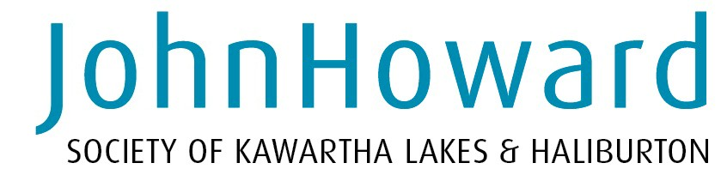

**PLEASE JOIN US**

**FOR OUR**

**ANNUAL**

**GENERAL MEETING**

**& IMPACT CELEBRATION**

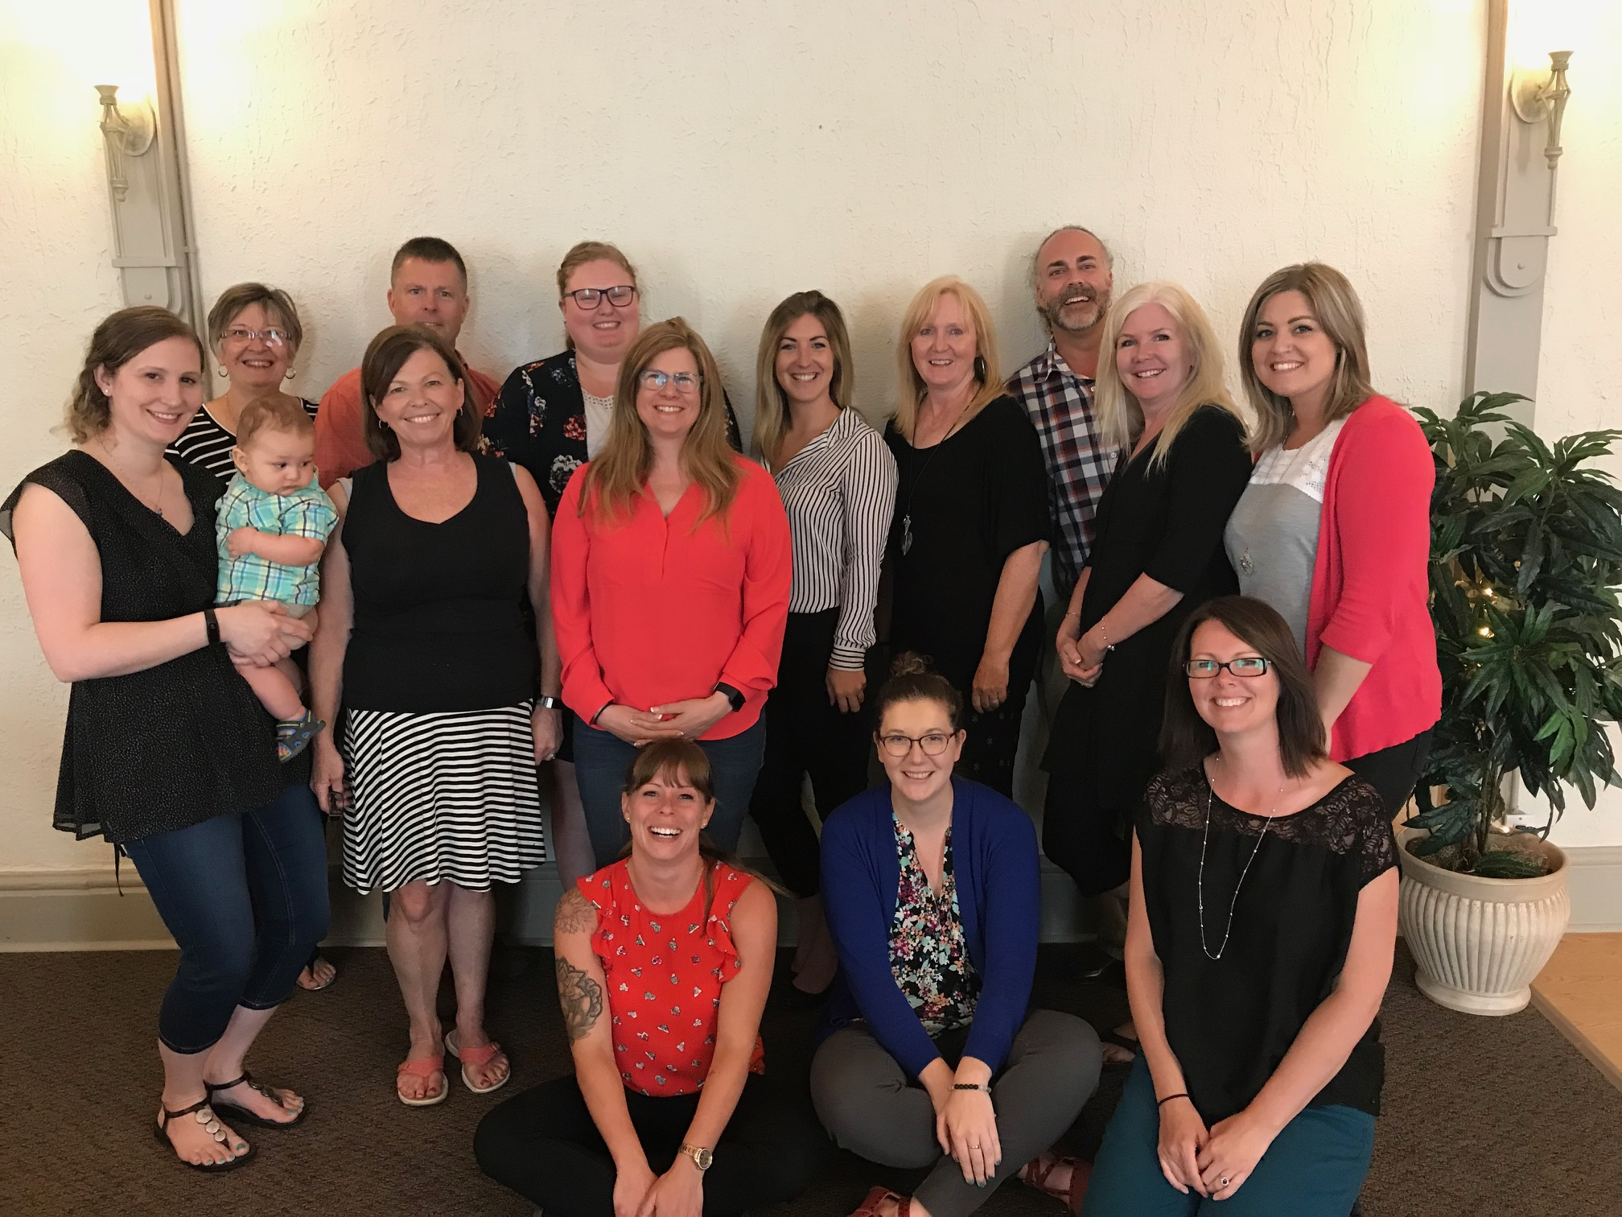

“When you’re surrounded by people who share a passionate commitment around a common purpose, anything is possible.”

~Howard Schultz, Starbucks